

**General Sir John Kotelawala Defence University**

**Faculty of Computing**

**Department of Computer Science**

**Approach and Design Chapters**

**Driver Fault Detection and Management System for Police**

**Approach, , Design** Chapters of the Software Engineering Project undertaken in partial fulfilment of the requirements for the Bachelor of Science (Hons)

in Computer Science Degree program

By

**O/Cdt KPHS Karunanayake**

4432

Under the supervision of

**Mr. RPS Kathriarachchi**

Contents

4.0 APPROACH 3

4.1 Introduction 3

4.2 Hypothesis 3

4.3 Users 3

4.4 The Features 3

4.4.1 Functional Requirements 3

4.4.2 Non- Functional Requirements 3

4.4.3 Technological Requirements 4

4.5 Inputs 4

4.6 Outputs 4

4.7 Process 4

4.8 Features 4

4.9 Summary 5

5.0 ANALYSIS AND DESIGN 6

5.1 Introduction 6

5.2 Analysis 6

5.2.1 Data Collection Protocols 6

5.3 Overall System Architecture 7

5.4 UML Model of Proposed System 7

5.4.1 Use Case of System 8

5.3.2 Sequence Diagram of System 9

5.3.3 Activity Diagram of System 10

5.4 Interface Design 10

Table of figures

Figure 1: Overall System Architecture

Figure 2: High level Use case for proposed system

Figure 3: Sequence Diagram the system

Figure 4: Diagram for process activities

Figure 5: Login Page

Figure 6: Sign Up Page

Figure 6: Home Page

# 4.0 APPROACH

## 4.1 Introduction

Chapter 3, discusses about the literature review and the identified problem and proposed solution. In this chapter, the approach will be taken to solve the identified problems. This includes the hypothesis, inputs, outputs, process related to the system, users of the system and the features of system will be described.

## 4.2 Hypothesis

By using Driver fault detection and management system, the traffic police can make their job much accurate and they can get a clear idea about the wrongful drivers and the locations that the drivers doing offences frequently.

## 4.3 Users

There will be many users who are using this application. Those are the traffic police officers who are recommended to use this.

## 4.4 **The Features**

### 4.4.1 Functional Requirements

* The systems should be able to analyse the data and generate a quality report for a wrongful driver with in a time period.
* The system should be able to detect the locations and times that drivers doing offences frequently.
* The system should able to store the all data regarding wrongful drivers.

### 4.4.2 Non- Functional Requirements

* The system should be reliable
* The system should provide user friendly interface with the all the needed option.
* The system should be efficient.

### 4.4.3 Technological Requirements

* Mobile or PC with an internet access.

## 4.5 Inputs

The main inputs of the system is the details of the wrongful drivers, their vehicles and he locations which they have done the offences.

## 4.6 Outputs

The output of the system is the details about the drivers who are doing offences constantly and the locations that the traffic police should pay more attention when checking the vehicles.

## 4.7 Process

Main steps will be as follows

* User can log in to the system by providing their email address and the password to the system. A new user can sign up and create a new account.
* User can enter the details about the wrongful drivers and their vehicles to the system.
* System will gather the information about the drivers for a period of time.
* System will learn about the wrongful drivers and the locations that drivers doing offences constantly using machine learning techniques.
* After a period of time the system will be given the drivers whose driving license should be cancelled and the locations and the time that the police should pay more attention when checking the vehicles.

## 4.8 Features

Key Features will be as follows,

* Ability to learn about the wrongful drivers and can give a prediction about them.
* Ability to predict the locations and times which drivers may doing wrongful driving often.
* Ability to compare the results with users expectation

## 

## 4.9 Summary

This chapter presented the hypothesis, input, output, features, users and process of the proposed solution. In particular I have explained the input processing concerning with the system. The outputs from the system are emotion recognized in the system. The overall features of the new system also have been pointed out at the end of the approach section.

The next chapter will present the design of the proposed system.

# 

# 5.0 ANALYSIS AND DESIGN

## 5.1 Introduction

This chapter elaborates on the analysis and design of the system. Firstly, this chapter presents the analysis of the project domain and the second section concludes with the proposed design of the solution. The analysis section describes on the data gathering protocols, how the data was analysed, and the overall summary of the data analysed. The design section describes the design of the developed system with using different UML diagrams and architecture diagrams. The components and modules of the system and their relationships have been elaborated using use case diagrams. And here discuss about what each component does in the system.

## 5.2 Analysis

### 5.2.1 Data Collection Protocols

The data was collected from the main users of the system. Mainly the data which was gathered by the traffic polce officers will be stored in a data base. These data points will be gathered first.

The data which will stored by the user are as follows

* DATE : Date that driver got caught by doing a offence on road .
* TIME : The time driver got caught
* Registered Province : Vehicle registerd province
* Vehicle Type
* Drivers’ Licen NO: License card number of the driver
* Offence : Type of offence that drver did
* Location : The location that driver got caught
* Police Station: The police station which that traffic police officer belongs.
* PC SVC No : Service number of the Police officer.
* Amount Of Fine : Amount of fine to be charged.

## 5.3 Overall System Architecture

Architectural design is the first illustration of the overall structure and the main components of this proposed system. The total structure is based on how it would suit the software architecture and how to integrate that with users and the database. Overall system will be split in to three layers’ names as presentation layer, application layer and data layer. Overall system architecture of the proposed system is given below.

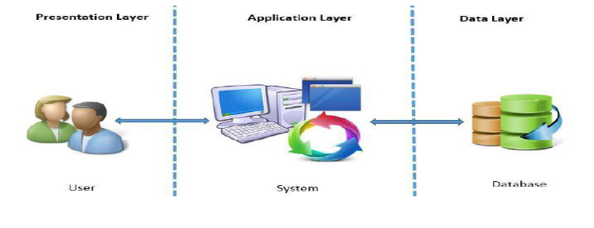

Figure 1: Overall System Architecture

## 5.4 UML Model of Proposed System

The main purpose of using UML to design was to identify the user requirement in as clearly as possible. The UML modelling depicts the correct user interaction with the system and the process flow. And also, the entities and relationships between them. The UML diagram types selected in analysing the business requirement is as follows,

* Use Case Diagram
* Sequence Diagram
* Activity Diagram

### 5.4.1 Use Case of System

Use case diagrams are considered for high level requirement analysis of a system. So, when the requirements of a system are analysed the functionalities are captured in use cases**. Use case diagrams** are usually referred to as [behaviour diagrams](http://www.uml-diagrams.org/uml-25-diagrams.html#behavior-diagram) used to describe a set of actions ([use cases](http://www.uml-diagrams.org/use-case.html)) that some system or systems ([subject](http://www.uml-diagrams.org/use-case-subject.html)) should or can perform in collaboration with one or more **external users** of the system ([actors](http://www.uml-diagrams.org/use-case-actor.html)). Each use case should provide some observable and valuable result to the actors or other stakeholders of the system.

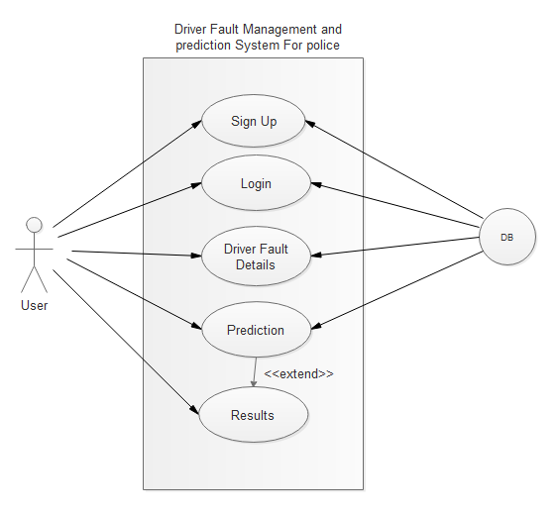

Figure 1: High level Use case for proposed system

#### 5.4.1.1 Scenarios of the use case by the side of User

**5.4.1.1.1 Sign Up**

|  |  |
| --- | --- |
| Use Case | Sign Up |
| Pre-condition | User should have the internet connection |
| Flow of events | User can go to the Login page by using the internet browser.  As a new user he must sign up as new user to the system. |
| Alternative Path | * System provide an error message for these reasons,   1. User must give a valid e-mail address   * If a user gives valid e-mail address, password and other related details he will be recognized as a valid user |
| Post Condition | User can enter to the login page after registered in the system successfully. |

**5.4.1.1.2 Login**

|  |  |
| --- | --- |
| Use Case | Login |
| Pre-condition | User should go to the login page. |
| Flow of events | 1 User can enter the e-mail address and the password to login  2. System will check with the user table and recognise the user |
| Alternative Path | * If user is a new user he can press the “New User” user button and go to the Sign Up page. |
| Post Condition | After log in properly the user can go the home page of the data base. |

**5.4.1.1.3 Driver Fault Details**

|  |  |
| --- | --- |
| Use Case | Driver Fault Details |
| Pre-condition | Details of the drivers who getting caught to the police by doing traffic offences should be recorded. |
| Flow of events | User can enter the details in form which contains in the home page. |
| Post Condition | Return to home page again after user submittec the details to the data base. |

**5.4.1.1.4 Prediction**

|  |  |
| --- | --- |
| Use Case | Prediction |
| Pre-condition | User can go to the prediction page. |
| Flow of events | 1. User can train the existing data by pressing the predict button. |
| Alternative Path | * User can go back and add more data. |
| Post Condition | The system will generate prediction results. |

### 5.3.2 Sequence Diagram of System

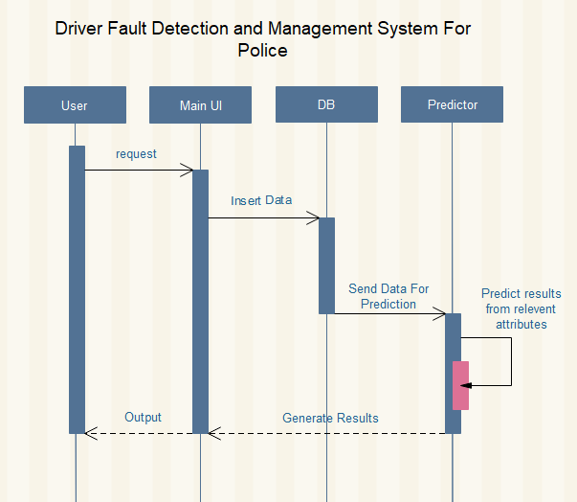

Figure 2: Sequence Diagram the system

### 5.3.3 Activity Diagram of System

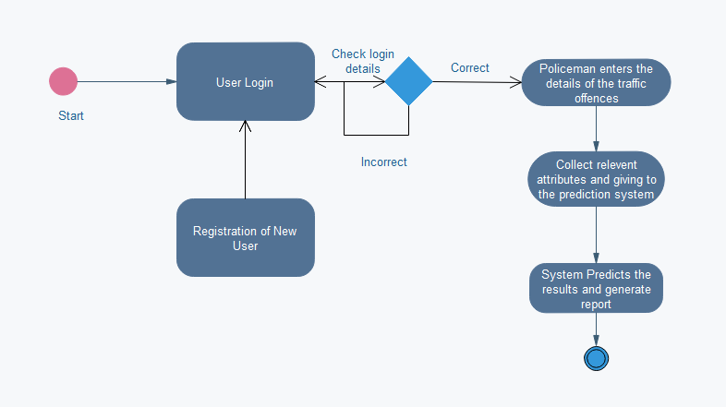

Figure 4: Diagram for process activities

## 5.4 Interface Design

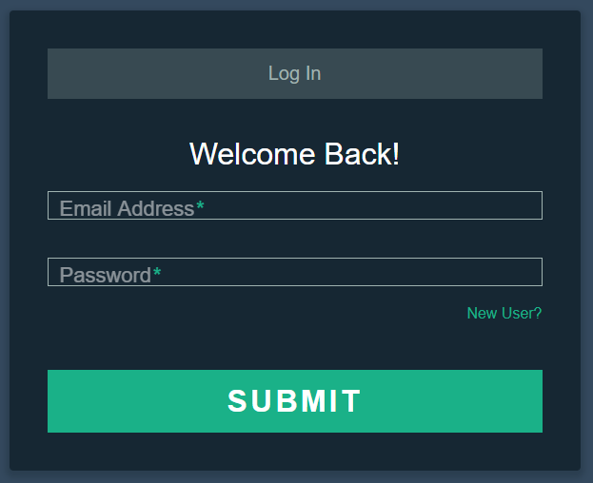

Figure 5: Login Page

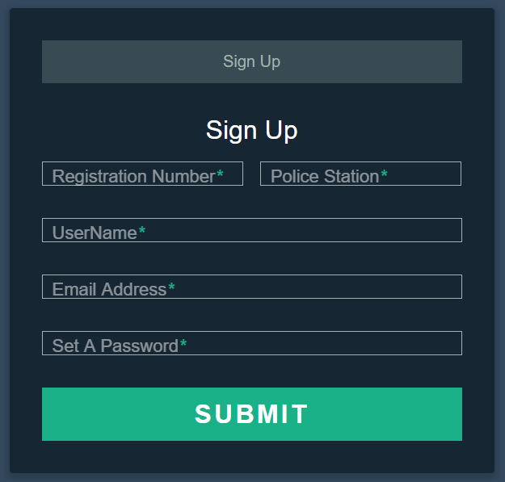

Figure 6: Sign Up page

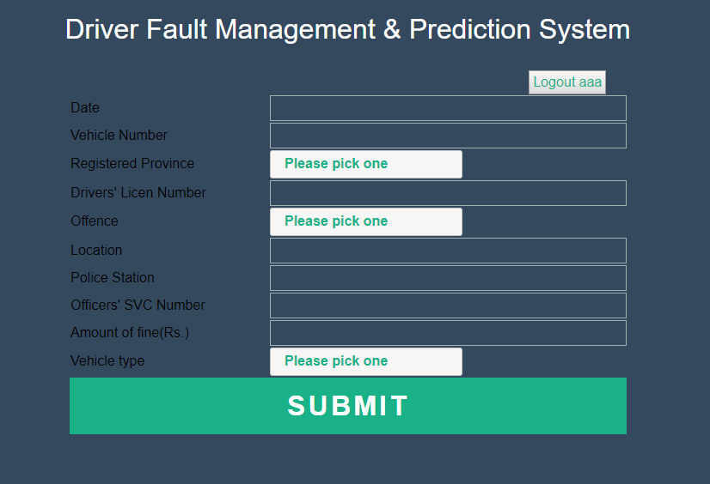

Figure 7: Home page